USER’S

MANUAL

Hakstock E-commerce Website

April, 2016

Abdulhakeem Usman
Revision Sheet

Release No. | Date | Revision Description
Rev. 1 | 4/19/16 | Initial creation of manual.

USER'S MANUAL

TABLE OF CONTENTS

Page #

1.0 GENERAL INFORMATION 1-2
1.1 System Overview 1-2
1.2 Project References 1-2
1.3 Points of Contact 1-2
1.3.1 Information 1-2
1.4 Acronyms and Abbreviations 1-2
2.0 SYSTEM SUMMARY 2-1
2.1 System Configuration 2-1
2.2 Data Flows 2-1
2.3 User Access Levels 2-1
2.4 Contingencies and Alternate Modes of Operation 2-2
3.0 GETTING STARTED 3-1
3.1 Browsing Items 3-1
4.0 USING the SYSTEM 4-2
4.1 Admin Back-end 4-2
4.1.1 Manage Brands 4-3
4.1.2 Manage Categories 4-4
4.1.3 Manage Products 4-4
4.1.1 Manage Users 4-6
4.2 Adding Product to Cart 4-6
4.3 Shopping Cart/Checkout 4-8
4.4 View Account 4-11

GENERAL INFORMATION
This document overall is designed to serve as a user guide for the Hakstock E-commerce website. The General Information section explains in general terms the system and the purpose for which the e-commerce is intended.

1.1 System Overview
Hakstock is an e-commerce website designed for customers interested in purchasing goods of notable electronic items, and self-produced graphic clothing for a cheaper, suitable sale price. The website will use the combination of Amazon and e-Bay e-commerce models. The e-commerce website will allow any user to create an account to become a customer. The website will allow customers to search, filter, select, and add goods to a shopping cart. Customers will be provided with a sufficient idea of what they will be purchasing based on the product description and also reviews from other customers. The website will also allow an individual with an admin account to manage the inventory with full create, retrieve, update and delete (CRUD) functionality with regards to the products stored in the database. Users will be able to receive confirmation email and shipping details after placing an order with us. As of now, the website is still under construction and has not yet been deployed [1].

1.2 Project References

- Hakstock Software Requirements Document [1]
- Hakstock Functional Specification Document [2]
- Hakstock Project Scope [3]

1.3 Points of Contact

1.3.1 Information
For information and troubleshooting purposes, please contact:

Abdulhakeem Usman
Project Admin
ibikunleusman@outlook.com

1.4 Acronyms and Abbreviations

Acronyms/Abbreviation | Definition
Admin | User with administrator privileges.
CRUD | Create, Retrieve, and Update Data
PHP | Server-side HTML scripting language.

SYSTEM SUMMARY

This section provides a general overview of the Hakstock e-commerce website in non-technical terminology. The summary outlines the uses of the system in supporting the activities of the user.

2.1 System Configuration

Hardware Components
- Operating System –

Software Components
The following components must be installed on your computer before you can use the ecommerce website:
- XAMPP Control Panel installed with:
  - Apache/2.4.17 (Win32)
  - OpenSSL/1.0.2d
  - PHP/5.6.15
  - Maria DB database server

Network Configuration
- Website server is provided via TCP/IP

2.2 Data Flows

Briefly describe or depict graphically, the overall flow of data in the system. Include a user-oriented description of the method used to store and maintain data.

2.3 User Access Levels

Admin User Level: The admin user level is intended for the store owner or any other personnel granted admin permissions. As an admin user you will have full access to add, delete and edit items in the back-end of the ecommerce website. (Note: items in this case may include users, user transactions, categories and products). If you'd like more than one person to have full permissions, it is possible to create multiple Admin users.

Editor User Level: The editor also contains the same features as the admin level excepts editor are only restricted to manage products. They cannot manage the users.

Customer User Level: The customers are individuals with shopping experience and are capable of navigating through a standard e-commerce application. A customer must possess basic understandings about computers and the internet. He or she should be able to perform the following functions using this system.

2.4 Contingencies and Alternate Modes of Operation

There is a significant time cost in building and loading large or manifold dictionaries into the system upon startup, so in the case of an emergency or failure requiring a reboot, the system will need to spend a significant amount of time (perhaps several minutes in the extreme case) assembling its resources before it can readily receive and process searches. Once this loading phase of the application is complete, however, normal operations can resume.

There are no secondary modes of operation in this application. It is either not running, or experiencing errors (web server or/and database server are not functioning properly).

GETTING STARTED

3.1 Browsing Items

3.1.1 Go to Website Home Page
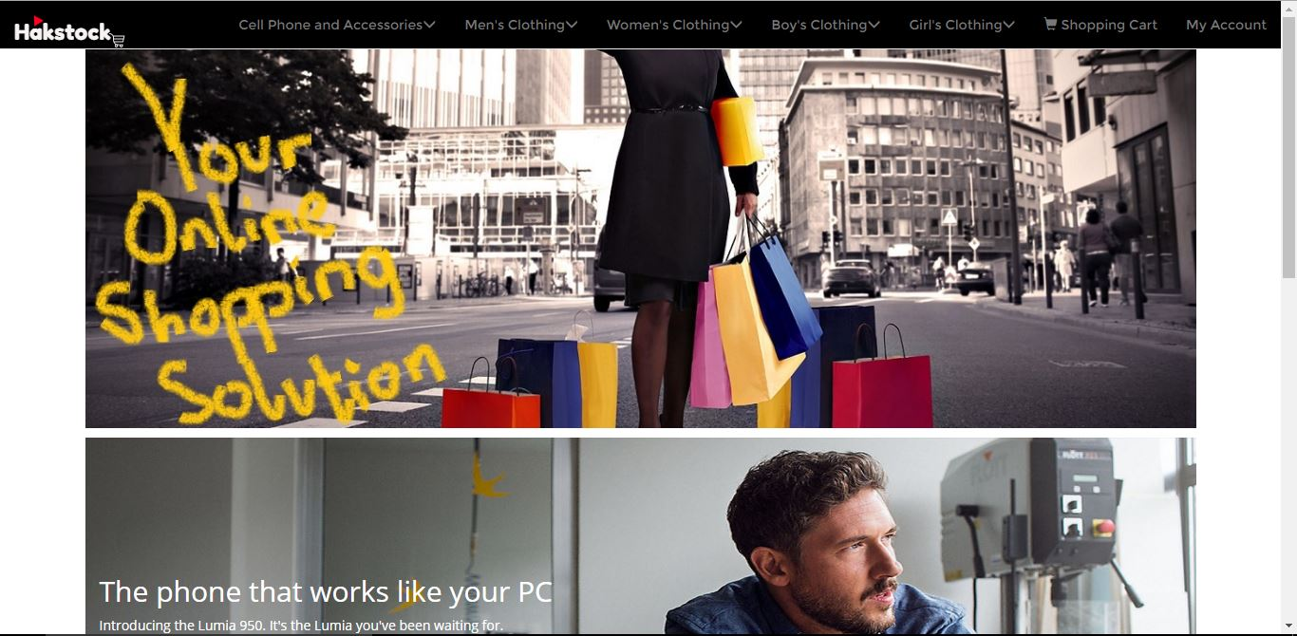

3.1.2 Use navigation bar to select preferred choice of categories to browse or scroll down to new products.

USING the SYSTEM

4.1 Admin Back-end
The admin system allows individuals with administrative or editing privileges to access the back-end and maintain the system. It provides an administrator with an interface to manage and maintain the system. The admin has access to all the information stored in the database and has the ability to change, or update users, items and properties of these entities [2].

To access the admin back-end, go to /admin/. The system prompts the user to enter their email and password.

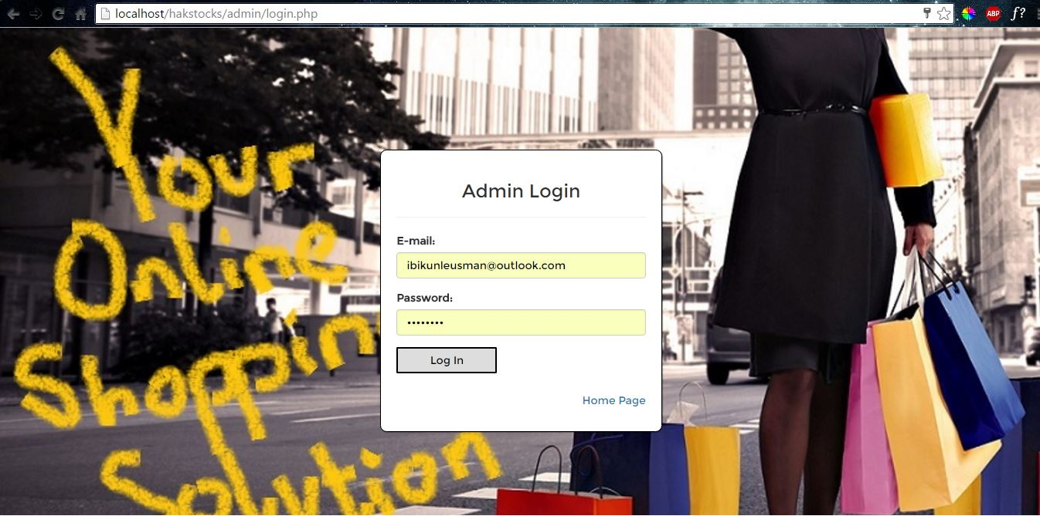

After the admin user has been successfully logged in, they are redirected to the admin home page which contains orders to ship, monthly sales, and low inventory stock.

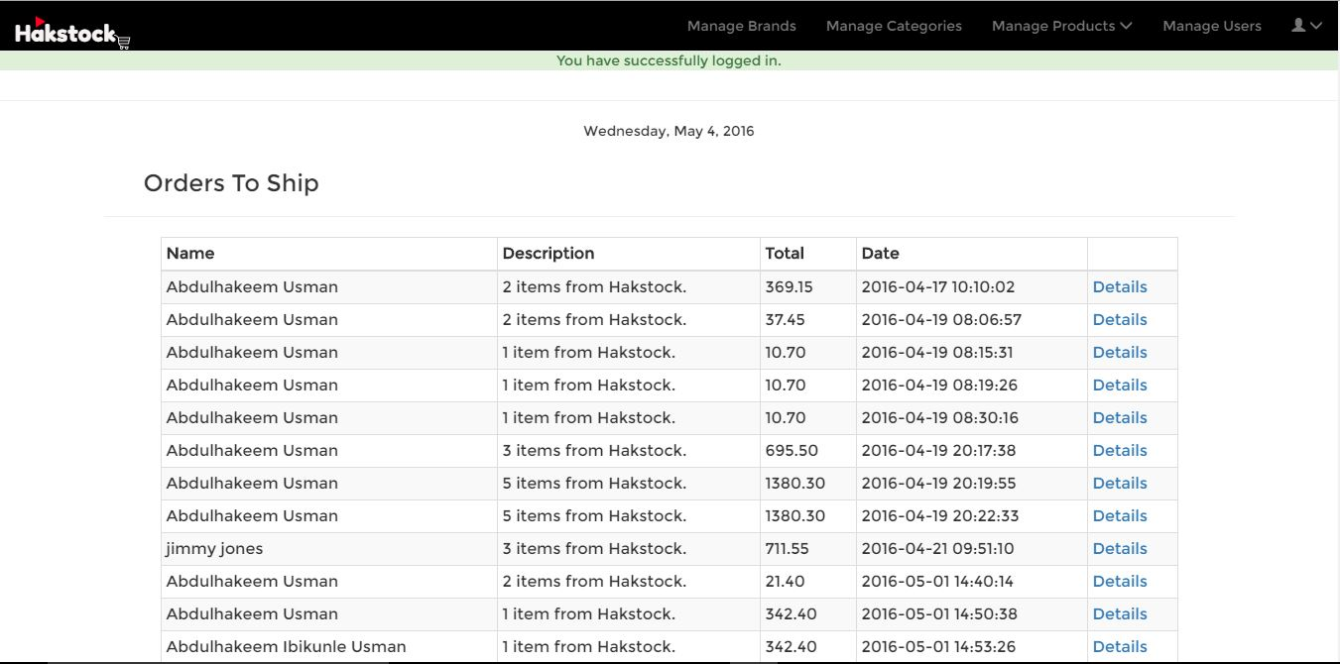
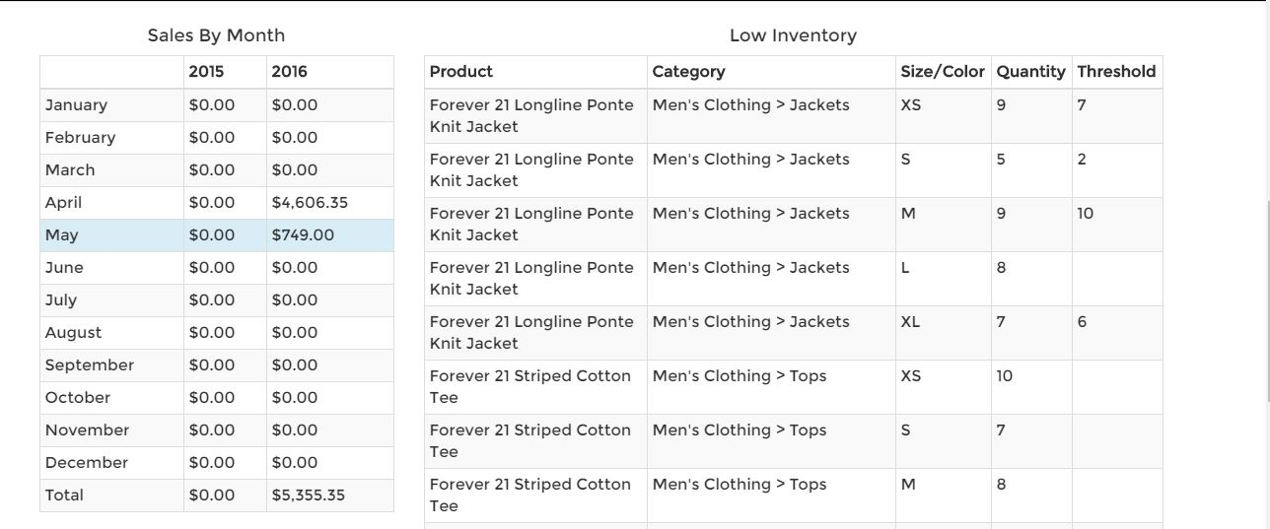

4.1.1 Manage Brands
To manage product brands, simply select the “Manage Brands” menu option on the navigation bar.

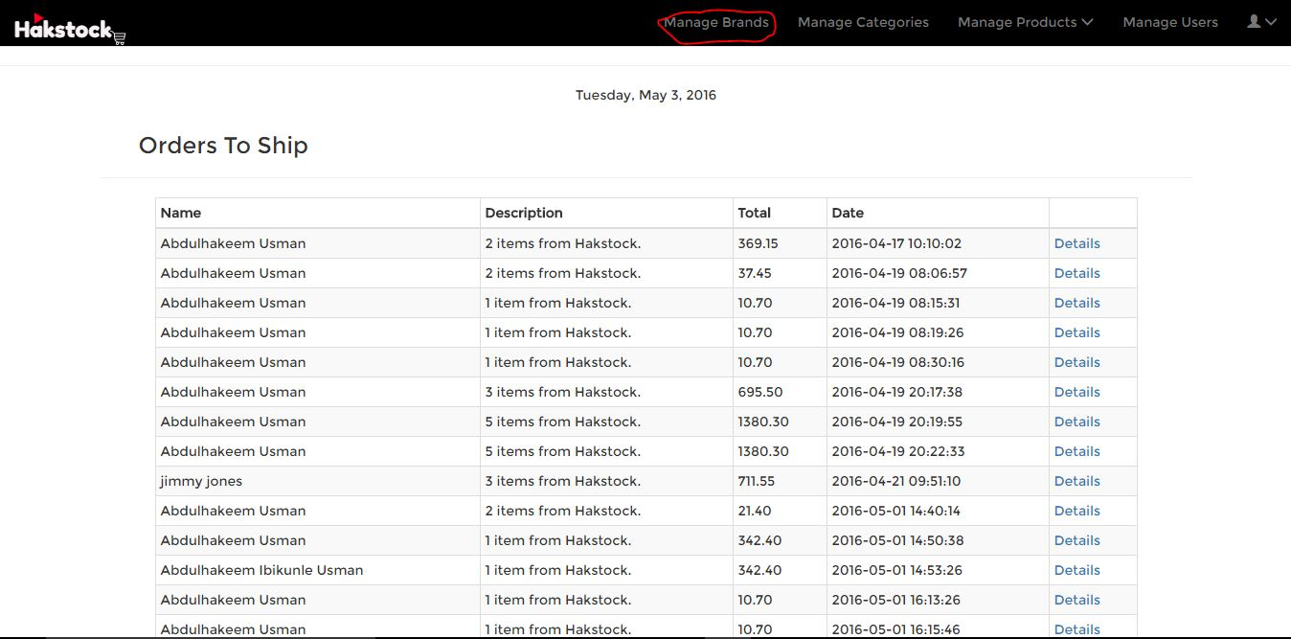

To add a brand, type in the brand who wish to add and click ‘Add Brand’ and to edit or delete, simply click ‘Edit’ or ‘Delete’

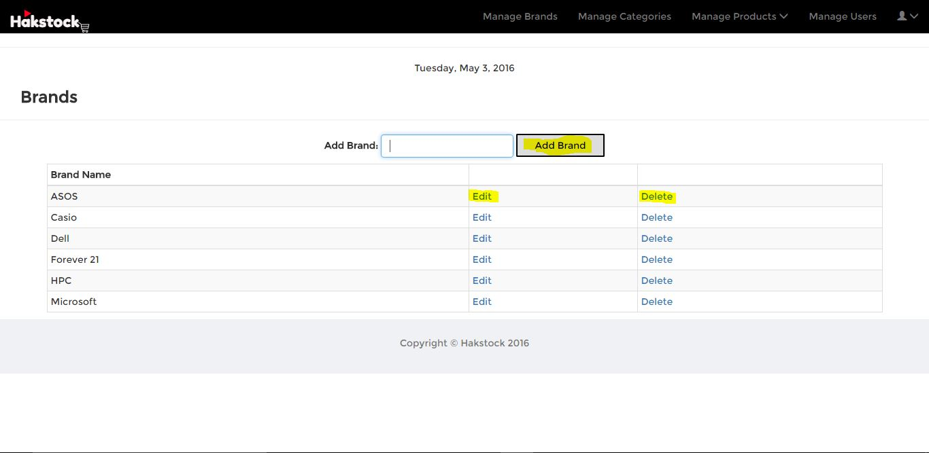

4.1.2 Manage Categories
To add a main category, select “Category” in Main Categories and type in a category you wish to add. To add a sub-category, select the main category you wish to enter the category. To edit or delete a category, simply click “edit’ or “Delete”.

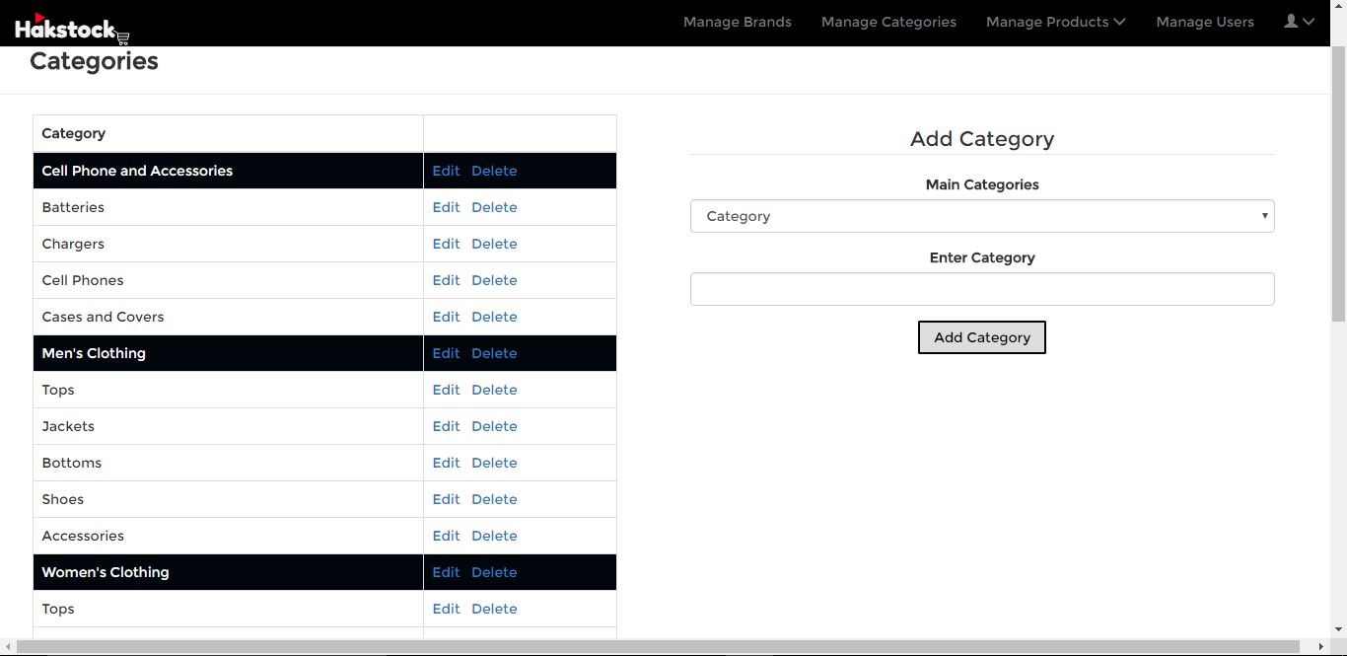

4.1.3 Manage Products
Manage Products has two options: Existing Products and Deleted Products. To view existing products (products still sold on website) simply click the ‘Existing Products’ option. To view deleted products simply click the ‘Deleted Products’ option.

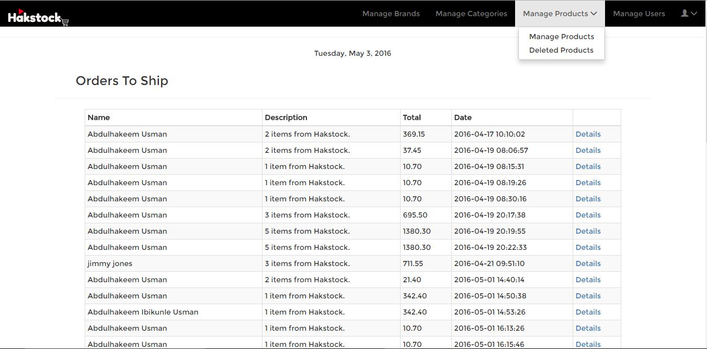

Under “Existing Products”, the admin user can add, edit, or delete a product. Once a product has been deleted, it is moved to the “Deleted Products” page. The admin can also decide what product to display on the New Arrivals section on the website’s home page by toggling the “New Arrival” button.

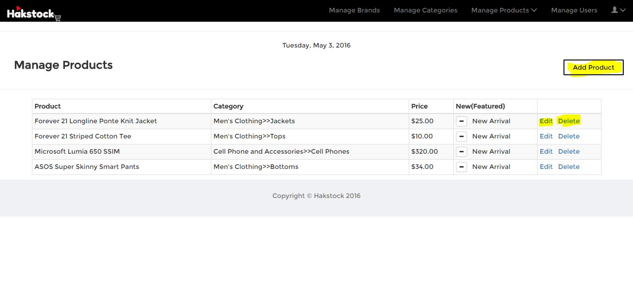
To restore deleted products, the user simply clicks on the “Restore” link close to the product intended.

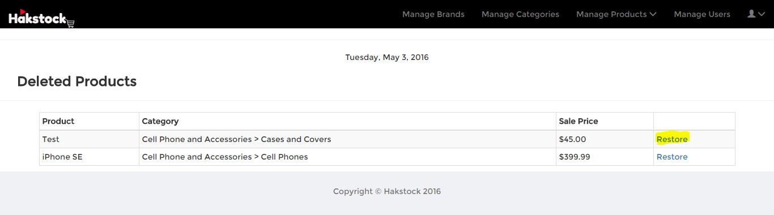

4.1.1 Manage Users
With this option, a user with admin privilege can add or delete a back-end user.

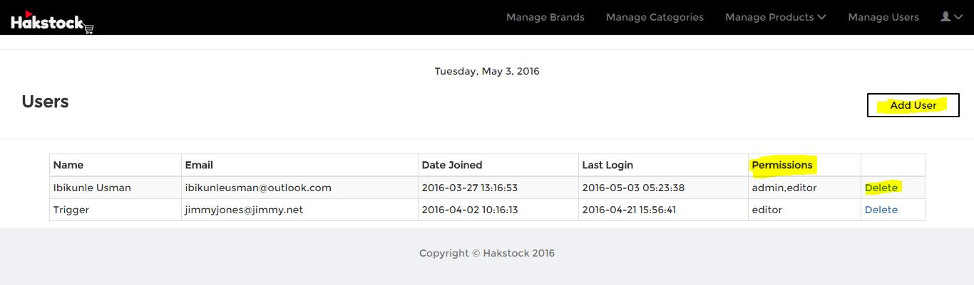

Note: User permissions can only be edited by the main admin and the user currently logged in.
This can be done by selecting the “Edit Profile” option under the Account menu.
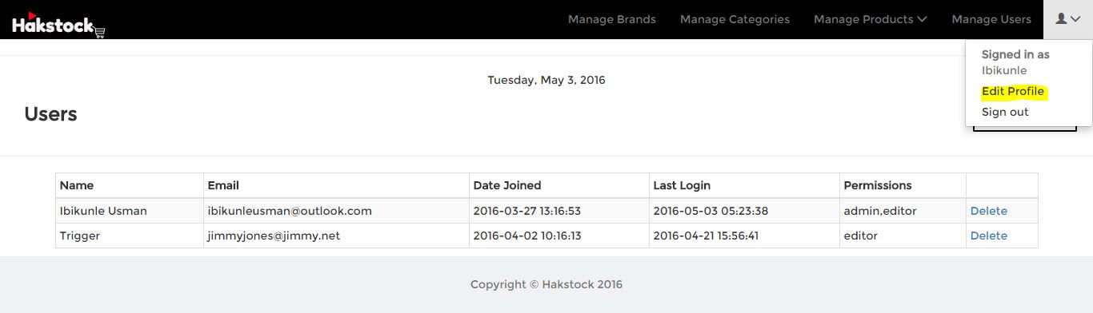

To sign out for the session, click “Sign Out”.

4.2 Adding Product to Cart
To add a product to your shopping cart, simply navigate to your preferred choice of items and click the “Quick Look” button.

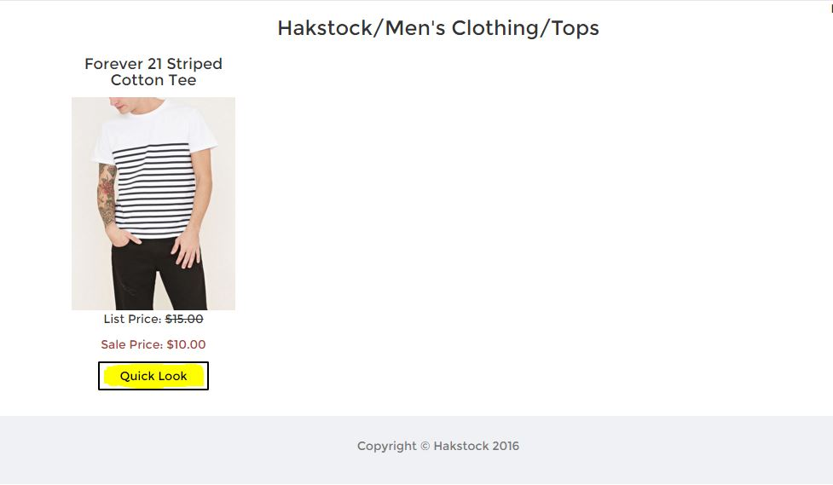

A dialog box containing the product description, quantity and size forms pops-up. Choose the size or color along with the quantity you wish to purchase.

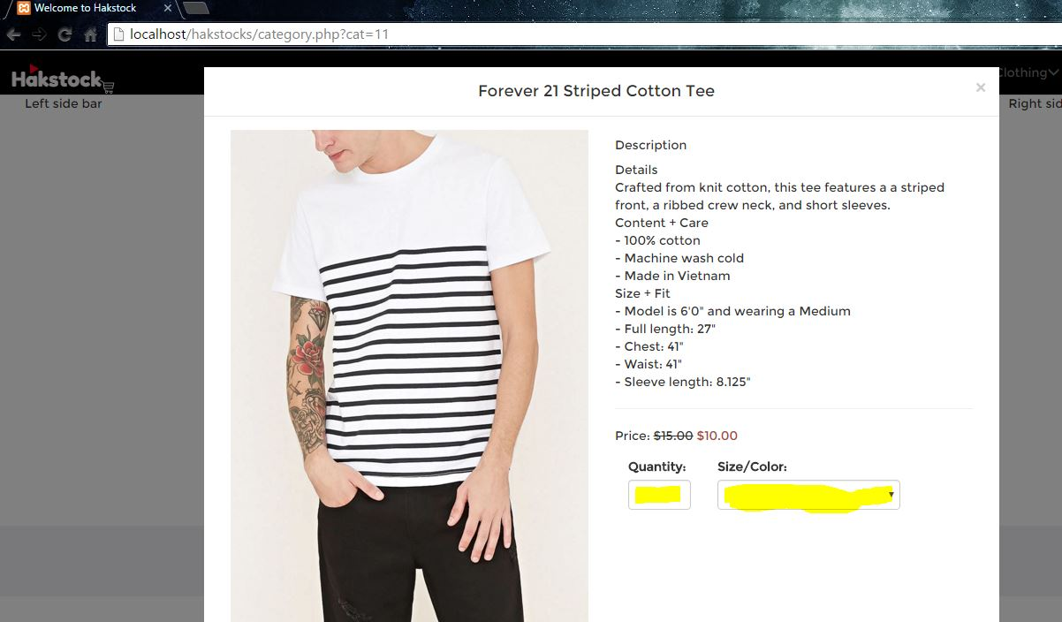

After selecting the size/color and quantity, click the add to cart button located at the footer of the modal if you wish to add the product to your cart.

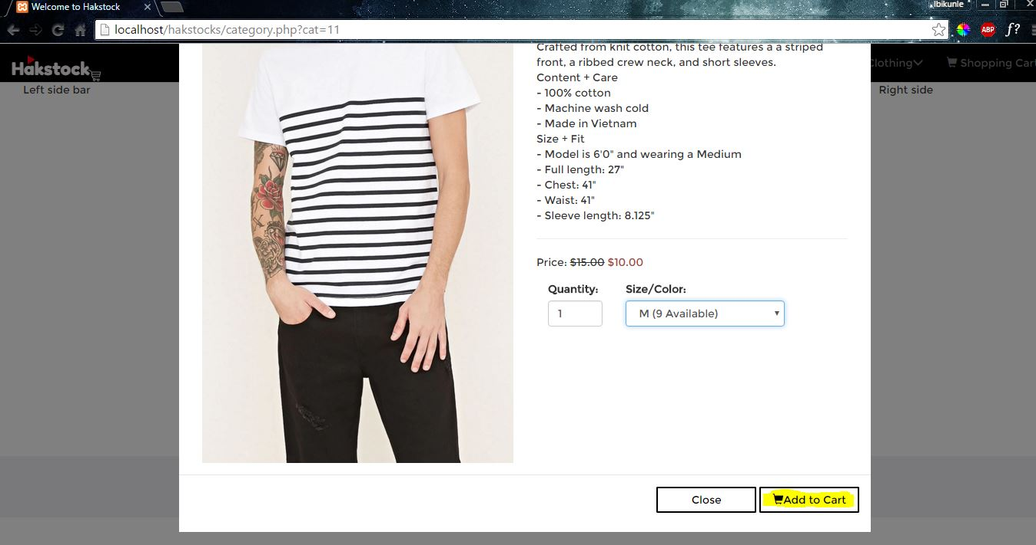

If you do not want to add the product to your cart, simply press the “X” button at the top-right corner of the modal and click on the “Close” button next to the “Add to Cart” button.\

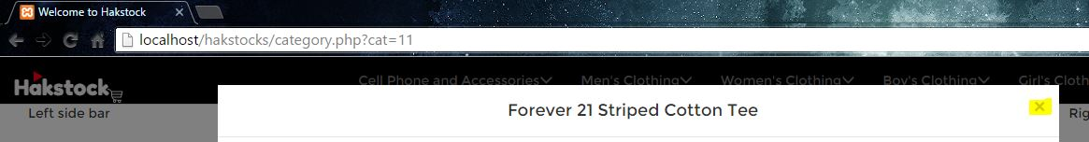

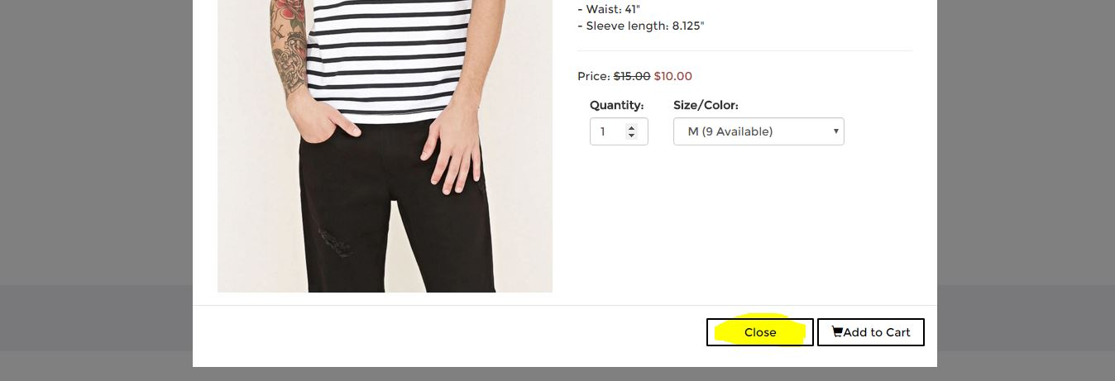

4.3 Shopping Cart/Checkout

4.3.1 View Shopping Cart
To view your shopping cart, simply click on the “Shopping Cart” menu on the navigation bar.

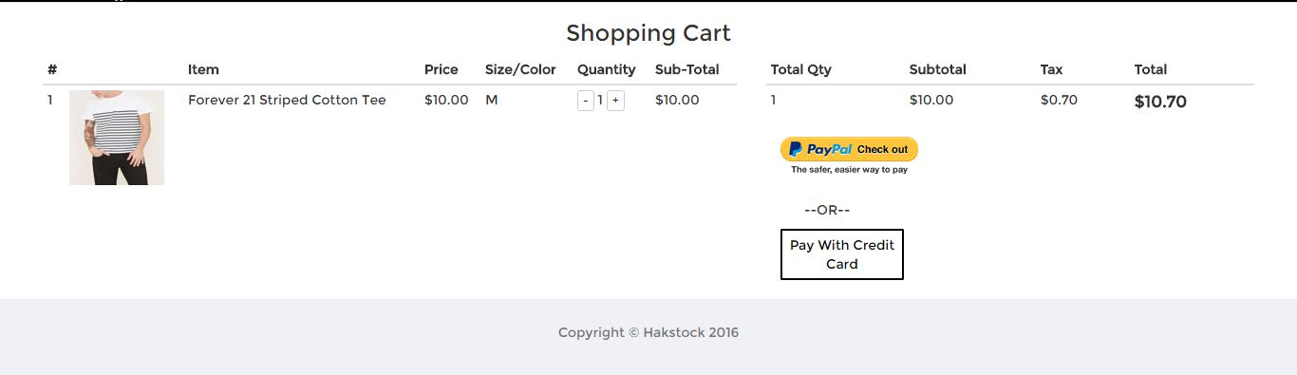

4.3.2 Checkout
Customers are provided with payment method options upon checkout: PayPal or Credit Card. A customer can only choose one method of payment per checkout. If the customer checkouts via PayPal, he or she will be redirected to a PayPal payment page as shown below.

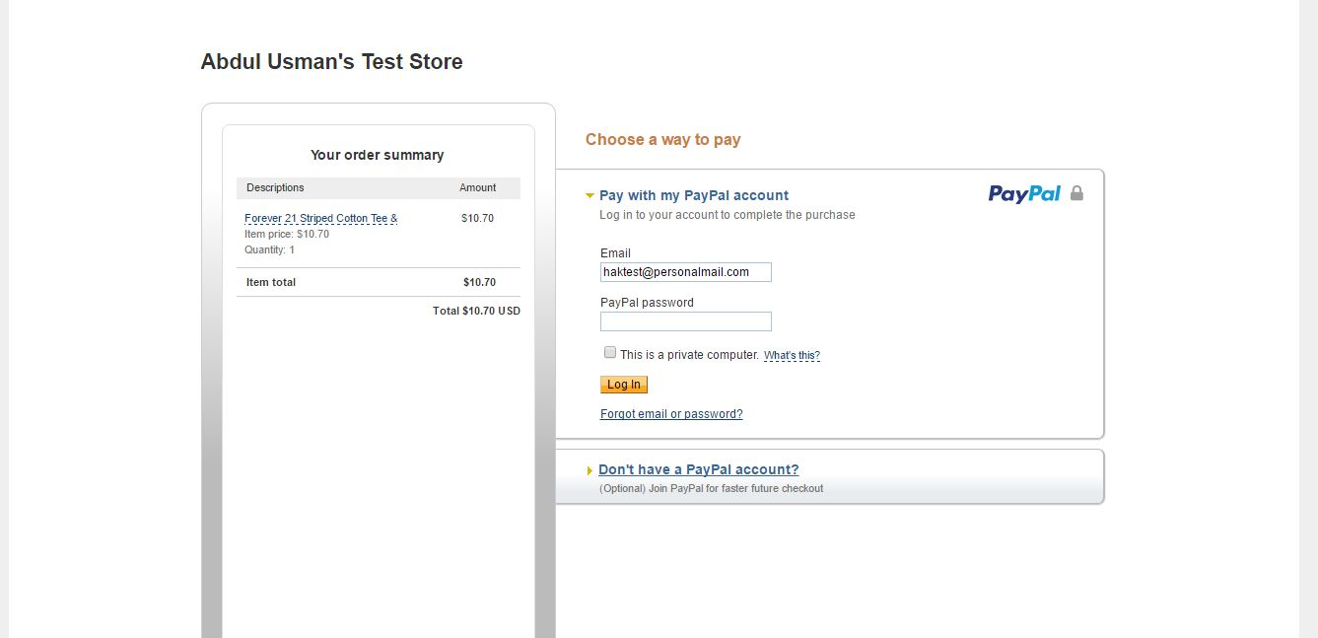

The customer is prompted to log in to their PayPal account to complete the purchase. After successfully logging in, the system asks if they wish to review their information before paying.

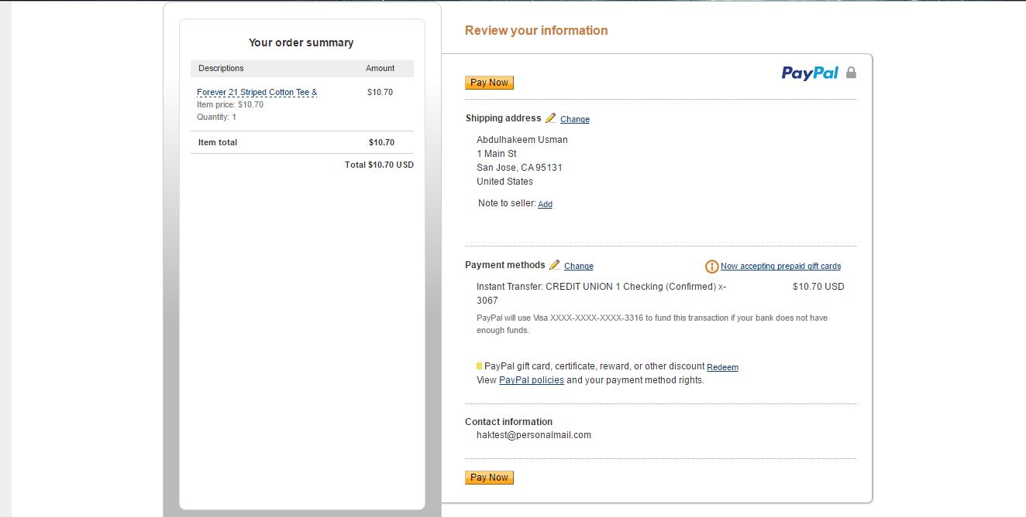

On successful payment, the system redirects the customer to a confirmation page.

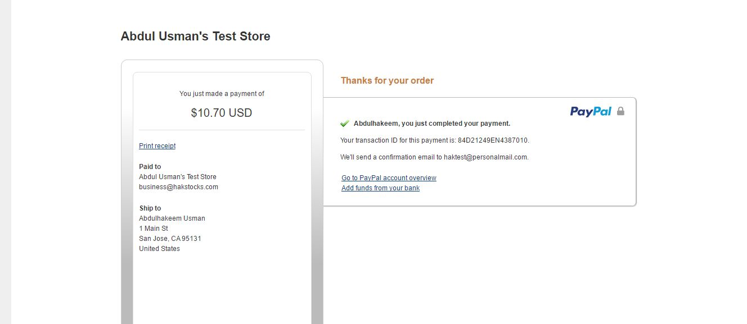

If the customer chooses to pay with credit card, he or she must follow the sequence as shown below:

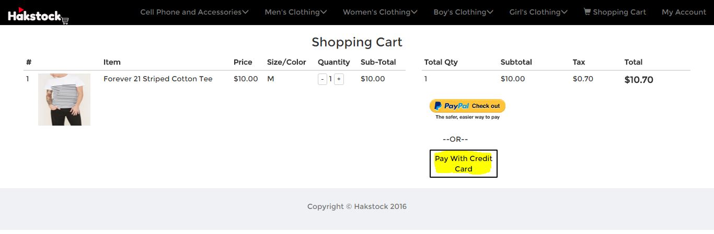

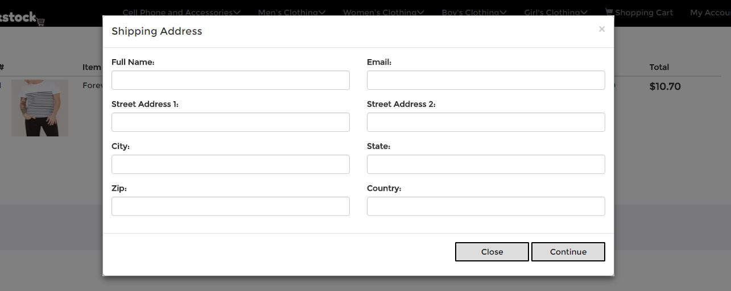

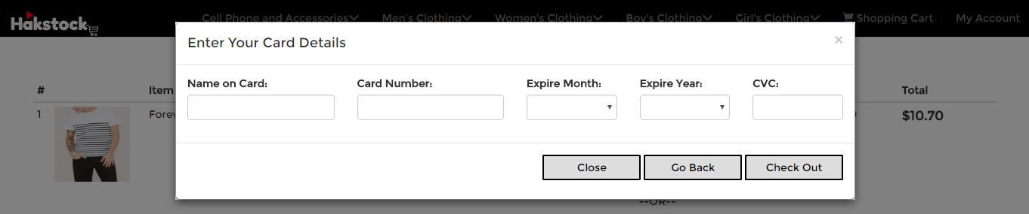

After the customer has entered all details correctly and has successfully purchased the item(s), the customer is redirected to a page where the message shown below is displayed. The shopping cart is consequently emptied.

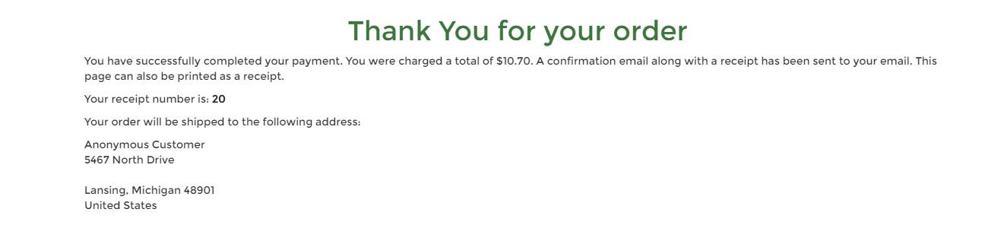

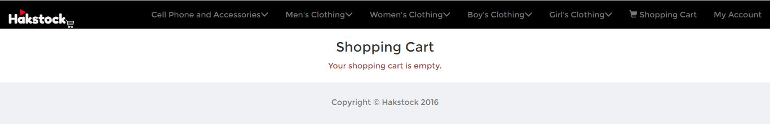

4.4 View Account
To view orders, simply click the “My Account” menu option. If the user is not logged in, the user is redirected to a login page. 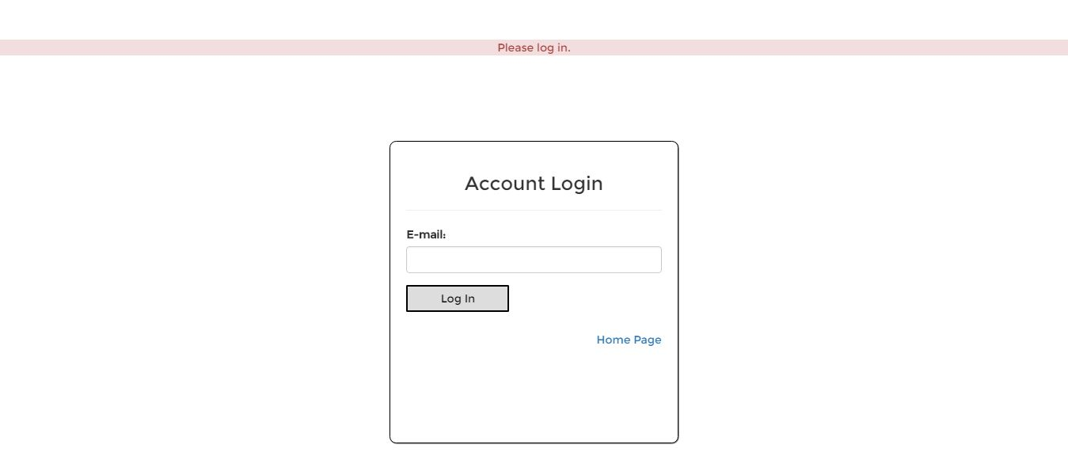

When the customer has successfully logged in, a table showing all previous orders is displayed on the page. To log out of the page, simply click on the “Log out” button located at the bottom of the table.

